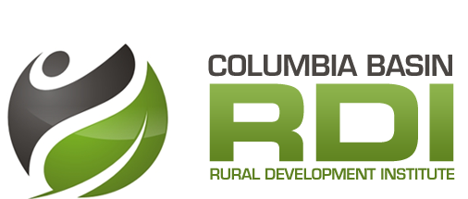
Climate Change Adaptation
  - Enabling Progress Measurement in Basin-Boundary Communities

Purpose
Pilot, evaluate, refine, and support uptake of the State of Climate Adaptation and Resilience in the Basin (SoCARB) indicator suite. SoCARB was developed in 2014 as a result of a research partnership between Columbia Basin Trust’s Communities Adapting to Climate Change Initiative and the RDI. It is a “made in the Basin-Boundary” approach to measuring progress in adapting to climate change.

Guiding Questions
- How well are Basin-Boundary communities adapting to climate change?

Deliverables: Complete SoCARB assessments for pilot communities (and other communities if the project progresses beyond the pilot phase), individual local government datasets.

- What specific supports do communities need to measure climate adaptation and implement research-based strategies for addressing climate-related risks to resilience?

Deliverables: Evaluation of the implementation process, action plan for addressing identified needs, report on best practices for sustained climate adaptation at the local scale, established data management systems at pilot local governments.

- How can existing research products be refined and mobilized to best address these needs?

Deliverables: Revisions to SoCARB to enhance feasibility of implementation, targeted guidance resources to facilitate uptake.

Key Partners and Advisors
Pilot local governments (Kimberley & Rossland [to be re-confirmed], others as they emerge)
Association of Kootenay Boundary Local Governments
Selkirk College School of Environment and Geomatics
Columbia Basin Trust
Possible others: Adaptation to Climate Change Team (SFU), Pacific Institute for Climate Solutions (UVic)
Rural Policy Learning Commons

Project Activities
Phase 1:
- Assemble project working group
- Confirm pilot local governments
- Establish community-specific steering committees
- Engage GIS co-op student to provide direct, on site data collection and management support to pilot local governments
- Implement pilots by collecting data, establishing data-management systems, analyzing data, reporting on results and recording challenges experienced during the process
- Research and report on options for actions that could address areas of need as identified by assessment results
- Share results of assessments with pilot local governments
- Evaluate implementation process and assess feasibility of expanding implementation to additional communities
- Based on results of evaluation, determine whether to continue with second phase of project

Phase 2:
- Using evaluation results, revise SoCARB suite to enhance potential for wide-scale uptake
- Develop guidance resources to support implementation and use of assessment results
- Promote availability and utility of SoCARB to Basin-Boundary local governments
- Engage additional co-op students to support implementation at Phase 2 local governments
- Track project success metrics, including uptake of SoCARB, use of guidance materials, and impact on action planning and implementation
- Contingent on completion of a sufficient number of assessments, complete a series of regional reports focused on: 1) compiling results 2) documenting the experiences of a rural region in measuring climate adaptation and taking related action.

Timeline and Possible Funders
1 year to pilot, evaluate and refine the SoCARB suite. Depending on the results of the initial phase, another 1-2 years could be spent rolling out the projects to individual communities as they express interest in participating, and documenting results at the scale of the region. The approach would be similar to that used for the Business Retention and Expansion Project.

The Real Estate Foundation of British Columbia often funds work intended to improve sustainability and resilience in communities. Applications to the next General Grant intake are due February 24, 2016.

