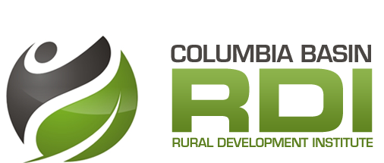
Rural Resident Attraction
  - Leveraging Local Assets to Attract & Retain Residents

Purpose
To better understand how local amenities can be linked and leveraged to attract and retain new residents in the Columbia Basin-Boundary region of BC.

Guiding Questions
- Who should the region target attraction and retention efforts on? What amenities are important to these target groups?

Deliverable: Literature review and Knowledge Briefs, related resources and related within region reports / strategies / asset maps reviewed and added to the RDI Research Repository, priority target audiences and related assets identified

- What assets has/is the region using to attract and retain new residents and what additional assets could the region be using?

Deliverable: Consolidated asset inventories mapped and added to the Digital Basin, priority asset ‘gaps’ addressed, Environmental Scan of existing strategies, activities and related marketing materials

- What are the ways in which the region is, and could be, linking and leveraging assets and existing efforts to attract and retain new residents?

Deliverable: New partnerships formed that link existing efforts (asset inventories, marketing activities), new and/or refined attraction and retention projects that link and leverage assets

- How successful have asset-based attraction and retention efforts been? What challenges have been encountered? What innovations have emerged?

Deliverable: Research Report / Research Briefs highlighting key literature, research findings, best practices from other jurisdictions, lessons learned from within region, and success stories and / or innovation profiles

Key Partners and Advisors
Imagine Kootenay (regional workforce and investment attraction partnership)
Destination Marketing Organizations (DMOs) and Kootenay Rockies
Doctor Recruitment Coordinators
Industry HR Departments
Public Sector HR Departments
School Districts
Selkirk College’s Teaching and Learning Institute and Selkirk Geospatial Research Centre
College of the Rockies Inspire Centre
Association of Kootenay Boundary Local Governments
Columbia Basin-Boundary Economic Development Practitioners Network
Kootenay Workforce Development Initiative
Kootenay Real Estate Board
Innovation Councils
Academics (with place-based / amenity-based expertise)
Chamber of Commerce
Cultural amenity groups (Arts Councils, CKCA)
Natural/Environmental amenity groups (recreation, parks, trails, etc)

Project Activities
- Literature Review

- Environmental Scan – identify who is working on retention and attraction and the scope of their efforts

- Review related plans, strategies, and assets mapped from the past 5-7 years

- Undertake new research as required to better understand assets linked to target audiences (e.g. survey new home buyers, past graduates, new immigrants, new doctors; interviews &/or focus groups with HR Directors, economic development practitioners, doctor recruiters, DMOs, etc.)

- Address any gaps in existing inventories &/or build new inventories relevant to target audiences, consolidate and map assets on Digital Basin

- Share asset inventories, maps and best practice strategies/resources with key partners involved in attraction and retention and encourage collaboration across groups

- Work with pilot communities / corridors to support the identification of target audiences and facilitate related mapping exercises, and identify emerging opportunities and/or partnerships focused on linking and leveraging assets

- Encourage stakeholders to consider regional-level strategies to attract and retain new residents based on applied research findings

Timeline and Possible Funders
2-3 year project beginning in April 2016. RDI will provide core funding from annual CBT contribution, key partners and pilot communities to provide in-kind support, funding could be leveraged with the Vancouver Foundation.

