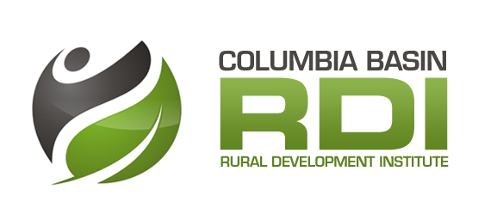Place-Based Poverty Reduction

*Enabling Performance Measurement in Basin-Boundary Communities*

## Purpose

To measure the Basin-Boundary’s progress on place-based poverty reduction efforts using indicators. Indicators are helpful for informing residents, organizations, and governments regarding key trends in poverty reduction, facilitating understanding of complex issues, evaluating the effectiveness of various poverty reduction measures, and motivating change.

## Guiding Questions

1. What actions are currently being undertaken to reduce poverty in Basin-Boundary communities and how is progress being tracked?

*Deliverables: Content analysis of existing poverty reduction strategies/plans, inventory of existing initiatives and indicators (including related methodologies)*

1. What indicators are best positioned to measure poverty reduction progress overtime, what related data gaps exist, and what level of research support is required to address research-related capacity constraints?

*Deliverables: State of Poverty Reduction (SoPR) in the Basin-Boundary indicator suite developed, action plan for addressing identified data and support needs*

1. Are Basin-Boundary communities making progress on their place-based poverty reduction efforts?

*Deliverables: Complete SoPR assessments for pilot communities (and other communities if the project progresses beyond the pilot phase), individual community data sets and reports, regional data sets and reports*

## Key Partners and Advisors

Pilot communities (Lower Columbia, Nelson, Cranbrook, Revelstoke)

Social non-profit organizations and Social Planning Councils / Networks

Community Foundations (explore links to Vital Signs)

Association of Kootenay Boundary Local Governments

Columbia Basin Trust

Columbia Basin Boundary Economic Development Practitioners Network

Colleges and School Boards

Tamarack Institute

Canadian Centre for Policy Alternatives

Provincial Ministries (Interior Heath, Ministry of Children and Family Development, )

Canadian Community Economic Development Network

## Project Activities

Phase 1:

* Assemble project working group and confirm pilot communities.
* Work with community-specific steering committees.
* Develop the State of Poverty Reduction indicator suite[1] and identify data gaps.
* Secure available data from the Tamarack Institute and/or other data providers.
* Implement local level data collection and consolidation strategies - Engage students or local research assistants to provide direct, on site data collection and management support to pilot communities as needed.
* Establish data-management systems, analyze data, report on results and record challenges experienced during the process for each pilot community.
* Share results of assessments with pilot communities.
* Evaluate implementation process and assess feasibility of expanding implementation to additional communities.
* Based on results of evaluation, determine whether to continue with second phase of project.

Phase 2:

* Using evaluation results, revise SoPR suite to enhance potential for wide-scale uptake.
* Develop guidance resources to support implementation and use of assessment results.
* Promote availability and utility of SoPR to Basin-Boundary communities.
* Engage additional students/ research assistants to support implementation at Phase 2 communities.
* Track project success metrics, including uptake of SoPR suite, use of guidance materials, and impact on action planning and implementation.
* Contingent on completion of a sufficient number of assessments, complete a series of regional reports focused on: 1) compiling results 2) documenting the experiences of a rural region in measuring poverty reduction and taking related action.

## Timeline and Possible Funders

One year to develop, pilot and evaluate the SoPR suite and related methodologies. Depending on the results of the initial phase, another one to two years could be spent refining the SoPR suite and rolling out the projects to individual communities as they express interest in participating, and documenting results at the scale of the region. The approach would be similar to that used for the Business Retention and Expansion project and the State of Climate Adaptation and Resilience in the Basin projects. The McConnell Foundation through its RECODE funding stream funds post-secondary led initiatives that improve civic engagement and action. The next intake is Monday, February 29, 2016.

1. While it is anticipated a standardized suite of indicators will be developed and implemented, additional community-specific indicators may also be added to ensure local priorities are captured and measured